Business Formation Proposal

Date: {{ date }}

Business Activity | {{ business_activity }}
License Authority | International Free Zone Authority (IFZA)



IFZA is a leading Free Zone Community in Dubai with world-class infrastructure, state-of-the-art facilities, and business friendly regulations, making it an ideal destination for foreign investors looking to set up and grow their business. IFZA provides premium standards of business setup solutions for SMEs through our wide network of Professional Partners and Business Communities. IFZA provide premium standards in business setup solutions for micro, small and medium-scale enterprises through their network of Professional Partners and Government Authorities.

Approximate Costing of Company Incorporation

Business Formation-IFZA
Particulars | AED | USD | Remarks
{{#items}}{{label}} | {{amount}} | $ {{amount_usd}} | {{remarks}}{{/items}}
Total | {{total}} | $ {{total_usd}}

***Please note: - process will start after confirmation of payment, POP must be sent to a designated member)

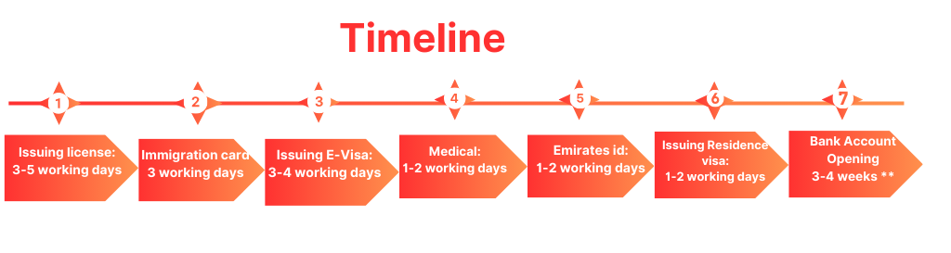

Add-on services provided by AB Capital

Add-on Services
Particulars | AED | USD
VAT Registration | 750 | 204
Corporate Tax Registration | 500 | 136
VAT Filing (Based on number of transaction) | 750 | 205
Accounting Services (Less than 10 transactions per month) | 700 | 190
Accounting Services (10 to 20 transactions per month) | 1000 | 274
Accounting Services (20 to 30 transactions per month) | 1200 | 330
Accounting Services (30 to 50 transactions per month) | 1500 | 410
Accounting Services (More than 50 transactions per month) | Rate will be customized | Rate will be customized

Terms & Conditions:

Documents Required
- Full Spread & Uncut Passport of the owner/partners & resident page (if any)
- High Resolution Passport size photo (white background only)
- Minimum 3 company names options
- Email ID of Investor/PartnerActive Contact Number and address of Partners.

Payment Terms
- 100% down payment to start the process

Bank Details:
Account Name - AB CAPITAL SERVICES FZE
Bank Name- RAK BANK
Account Number. -0372949069001
IBAN -AE120400000372949069001
SWIFT -NRAKAEAK
CURRENCY – AED
Scope of work

- Preparation & Submission of Application
- Assisting clients in submitting the KYC and accepting the application
- Issuing Trade License and legal documents.
- Submitting application for immigration card
- Submitting application for visas
- Assisting client for medical & emirates id
- Preparation of documents for bank account

Notes:
- The license fee is calculated based on the free zone authority price chart.
- All Government and Regulatory charges are borne by the Customer on an actual basis.
- Above are indicative charges current based on current promotions and might be variable.
- More than one business Activities should be from same field or extra charges will be applied as per authority.
- Branch company activity should match with the parent company.
- Depending on the nature of your business activity, you may need to submit additional documents to obtain approvals from other government bodies.
- *Plus, Applicable Taxes.

Contact: - Bharat Bajaj

+971-523655193

info@abacapital.ae www.abcapital.ae

